Exception reports – a step by step guide for supervisors

Exception Reports are used to indicate when doctors in training have been required to work outside of their agreed work schedule and allow the Trust the opportunity to address issues as they arise.

The trainees with put in exception reports for the following reasons:
- Differences in the total hours of work (including opportunities for rest breaks)
- Differences in the pattern of hours worked
- Differences in the Educational opportunities and support available to the doctor
- Differences in the support available to the doctor during service commitments.

What to do if your trainee submits an exception report…
- You should discuss the report with your trainee. Do not just complete it without discussion.
- You may wish to request more information from the trainee, discuss with ward staff, colleagues or rota co-ordinators to gather more information and insight before making a decision.
- Record any extra information and reasons for your decision in the response
- Provide education, support and feedback if appropriate to help avoid a recurrence.
- If you agree you must confirm an outcome ( TOIL or Payment or No Action )
- Record reasons for your decision and any other relevant information
- Support the process. Respond to reports in a professional manner and encourage your trainees to report freely.

For the practical steps of reviewing an exception report see below…

Step 1: Go to… Login Details (allocatehealthsuite.com)

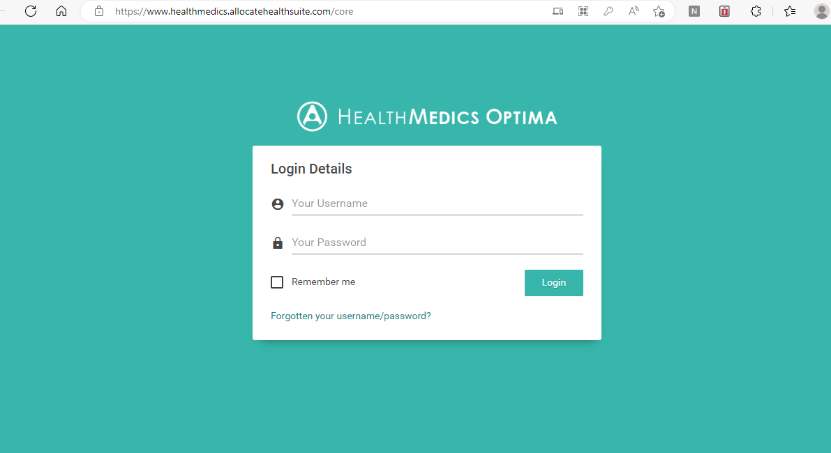

You should already have a login as it is the same for the e-job planning. If there are any issues contact exception.reports@bthft.nhs.uk

Step 2: When you have logged in click on Junior Doctor Portal

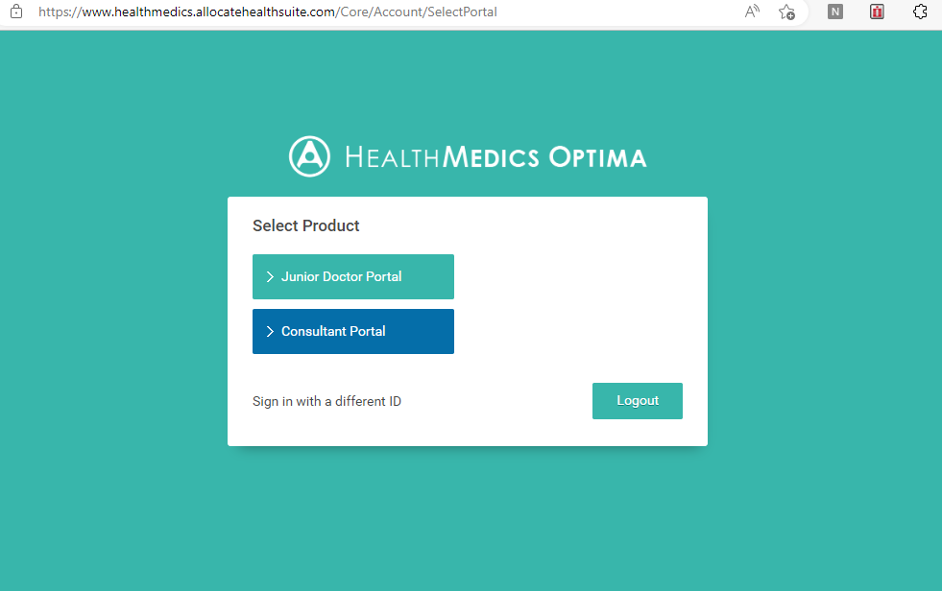

Step 3: When you click on the Supervisor tab it will show you if you have any live exception reports from your trainees. Trainees should send the report to you as their CS or ES but may also send it to you as a clinical lead if relevant.

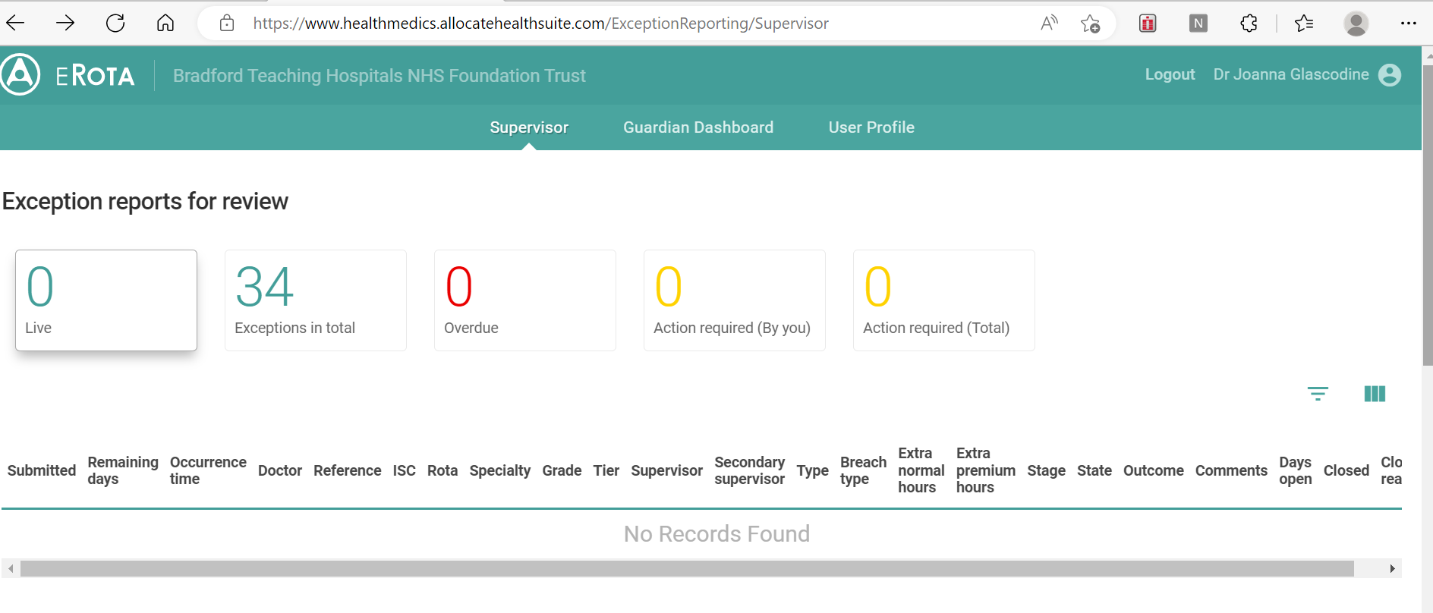

Step 4: When you open a live report it will look something the example down below. There may also be a more detailed explanation of the reason for the report included. There is a space for comments from the discussion between you and the trainee. Please then choose a meeting outcome which will be in a drop down box (no further action / payment / TOIL / work schedule review)

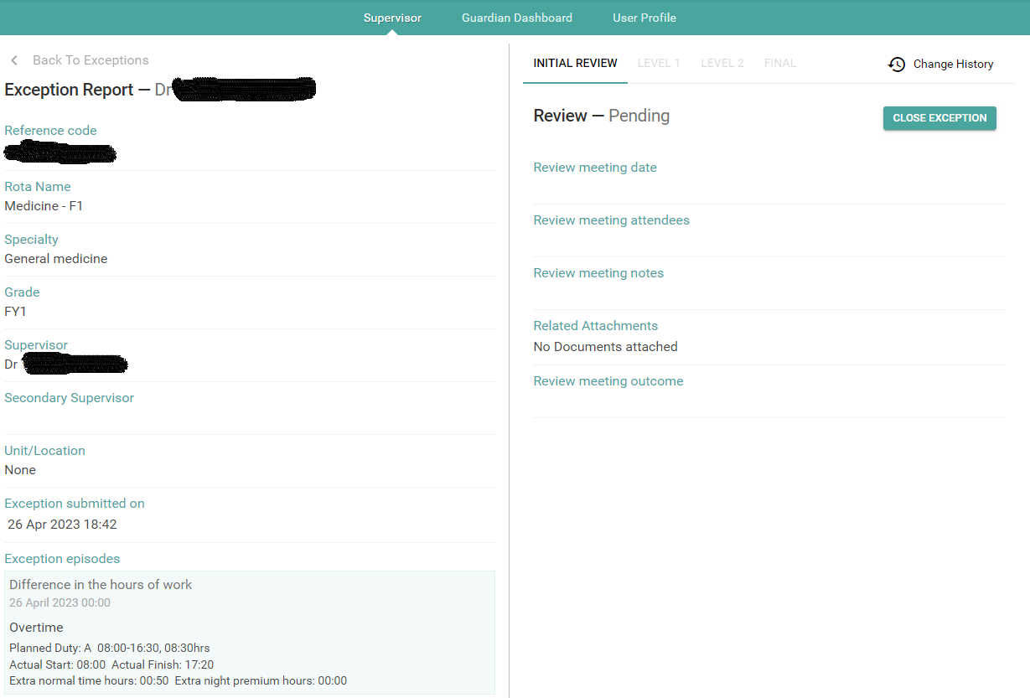

Step 5: If both yourself and the trainee agree on the outcome then you can close the report. If you disagree or would like to discuss further you can contact the GoSWH or the DME if there is an education issue. If the report remains open at the end of the quarter it will be reviewed and closed centrally by the Guardian.

Other useful links:

BMA how to exception report: Exception reporting using the Allocate eRota app - YouTube
NHS employers rota rules: Rota rules at a glance | NHS Employers

