How to exception report – a step by step guide

Step 1: Go to… Login Details (allocatehealthsuite.com)

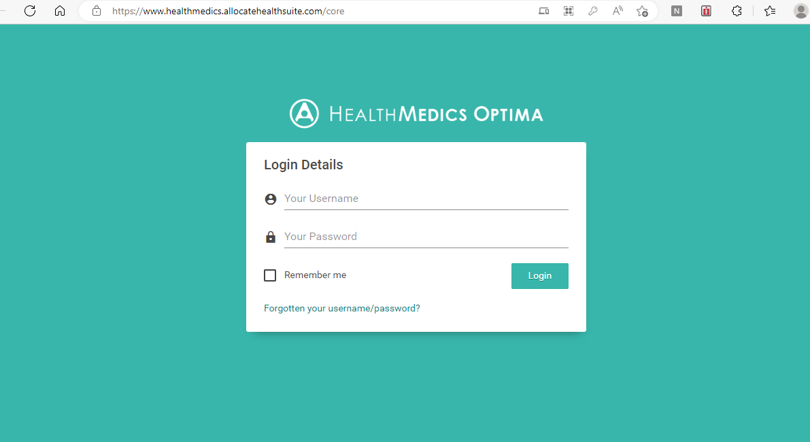

Your login should have been given to you at induction and should be the same in previous trusts that used Allocate. If there are any issues contact exception.reports@bthft.nhs.uk

Step 2: When you have logged in click on Junior Doctor Portal

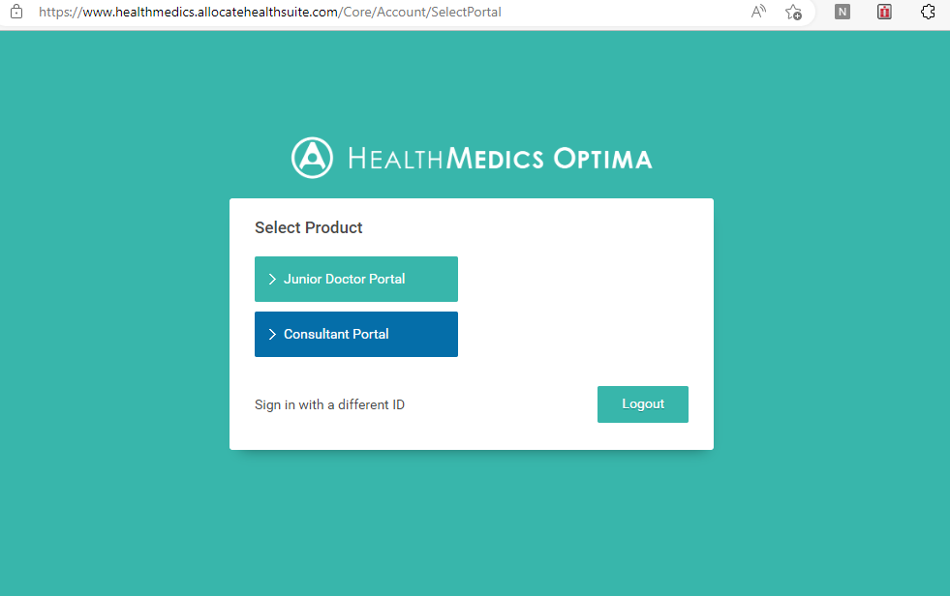

Step 3: When you are on the portal you will see a ‘Create New Exception’ button on the right side

Step 4: You need to include the following information…

  - Select your rota from the drop down menu
  - Select who you want your exception report to go to – most commonly this should be the Clinical Supervisor but could be the Education Supervisor. The Guardian of Safe Working automatically gets a copy of every report so you do not need to include them
  - Select the exception type (see details below)
  - Select the date and time this occurred
  - Enter details of the report e.g. the reason you stayed late / missed breaks and who it was escalated to at the time
  - Press submit

Types of exception reports
- Difference in hours worked - if there is a difference in total hours worked (early start / late finish) or missed breaks / rest. For staying late the ‘start time’ is the time you should have finished the shift according to your work schedule and the finish is when you actually left
- Difference in pattern of hours of work – if sequencing of shifts differs to work schedule
- Difference in educational opportunities
- Difference in the support available during service commitments

Trainees must raise immediate safety concerns to patients or doctors to their duty senior immediately in person or by phone. This should be followed up by an exception report in 24 hours with the Immediate Safety Concern (ISC) box ticked. Examples of Safe Working ISCs include if doctors working hours exceed safe limits, if gaps between working hours are reduced to below safe limits or if doctor staffing levels are below safe limits.

Step 5: Inform your supervisor you have submitted a report. Some supervisors are used to dealing with exception reports but some may need some prompting. If your supervisor does not respond it will be dealt with centrally by the Guardian but this will take longer.

Step 6: Outcome of the exception report will depend on the discussion with your Supervisor – the options are Payment (make sure the amount of overtime is clear), TOIL, no further action or change to work schedule. You may need to provide more information and do not have to accept the outcome from your Supervisor if you disagree. If the exception report is still open at the end of the quarter (Jan-Mar / Apr – Jun etc) then it will closed centrally by the Guardian.

Other useful links:

BMA how to exception report: Exception reporting using the Allocate eRota app - YouTube

NHS employers rota rules: Rota rules at a glance | NHS Employers

